PRODUCT DATA SHEET
DDAB
Synonyms | Didecyl Dimethyl Ammonium Bromide
CAS Number | 2390-68-3
Einecs Number | 219-234-1
UN No.
Molecular Formula | C₂₂H₄₈NBr
Molecular weight | 406.53382
Structural Formula | 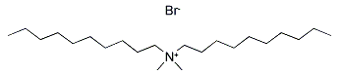
Product Grade | Industrial
Description  & Application | It has a wide range of uses and is often used as a catalyst, emulsifier, disinfectant, bactericide, anti-static agent, etc.
Safety Protection
Specification | Assay：50%, 70%，80%  Appearance (20ºC) ：Colorless to pale yellow clear liquid  Ph(1% aqueous solution)：4-8  Free amine and its salt ：≤2.5%
Package | 180kg/plastic drum or IBC
Shelf Life | 1year

