PRODUCT DATA SHEET
Benzalkonlum bromide
Synonyms | Benzalkonlum bromide
CAS Number | 7281-04-1
Einecs Number | 230-698-4
UN No.
Molecular Formula | C₂₁H₃₈BrN
Molecular weight | 384.4371
Structural Formula | 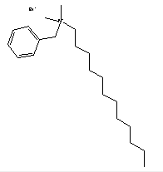
Product Grade | Industrial
Description  & Application | Widely used in sterilization, disinfection, antiseptic, emulsification, solubilization detergent, etc. Has similar performance with Geramine. Due to molecular bromine atoms instead of chlorine atoms, the killing performance is stronger than Geramine. Under the dosage of 10mg/L, the killing rate of Bromo-geramine to heterotrophic bacteria is 98.9%, while the killing rate of Geramine is 98.3%.
Safety Protection
Specification | Appearance:colorless liquid to yellow cream  PH（10% aqueous）:5-9  Density:0.968g/ml  Assay:80%,95%,98%
Package | 50、200kgs/palstic drum.
Shelf Life | 1year

