PRODUCT DATA SHEET
Acryloxyethyl dimethylbenzyl ammonium chloride
Synonyms | Acryloxyethyl dimethylbenzyl ammonium chloride
CAS Number | 46830-22-2
Einecs Number | 256-283-8
UN No.
Molecular Formula | C₁₄H₂₀ClNO₂
Molecular weight | 269.7671
Structural Formula | 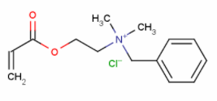
Product Grade | Industrial
Description  & Application | Paper Making
Safety Protection
Specification
  Appearance | Colorless to pink yellow transparent liquid
  Purity (m/m, %)≥ | 80
  Color ≤ | 100
  MEHQ (ppm) | 500
Package | 200kg plastic drum
Shelf Life | 1year

