PRODUCT DATA SHEET
HEDP.NA4
Synonyms | Tetra sodium of 1-Hydroxy Ethylidene-1,1-diphosphonic acid
CAS Number | 3794-83-0
Einecs Number
Molecular Formula | C₂H₄O₇P₂ Na₄
Molecular weight | 294
Structural Formula | 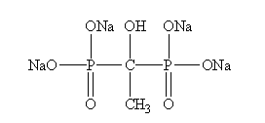
Product Grade | Industrial
Description  & Application | HEDP Na4, widely used in electric power, chemical industry, metallurgy, fertilizer and other industrial circulating cooling water and low pressure boiler, oil field water injection and oil pipeline of anti-scaling gentle erosion; HEDP, Na4 in the textile industry, cleaning agent for metal and nonmetal peroxide stabilizer and fixing agent, printing and dyeing industry, without cyanide electroplating complexing agent, daily-use chemical additives.
Safety Protection | 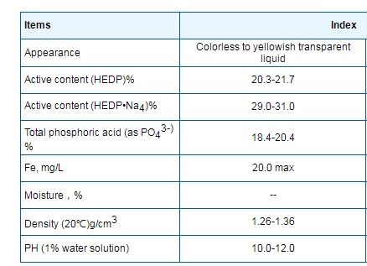
Specification
Package | 250kg/drum.,Stored in cool and dry place.
Shelf Life | 1 year.

