PRODUCT SHEET
PAPE
Synonyms | Polyhydric alcohol phosphate ester
Structural Formula | 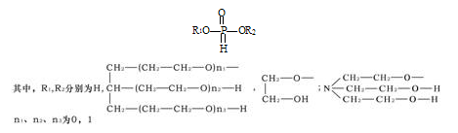
Product Grade | Industrial
Description  & Application | Polyol phosphate is a new water treatment agent with good scale and corrosion inhibition properties. Due to the introduction of several polyoxyvinyl groups into the molecule, not only the corrosion inhibition performance is improved, but also the scale inhibition and sediment dispersion ability of calcium scale are improved. It can inhibit the deposition of barium and strontium scales in water beyond the control of existing scale inhibitors in China. It can also inhibit the deposition of insoluble salts such as calcium carbonate and calcium sulfate in water. It has a cathodic protection effect on steel. The corrosion inhibition effect is better than that of similar products in China. Polyol phosphate is well miscible with water stabilizers such as polycarboxylate, organic phosphonate, inorganic phosphate and zinc salt.  Polyol phosphate is used as scale inhibitor for oil field water injection collection (especially recommended as a substitute for Nalco Visco 953), corrosion and scale inhibitor for industrial cooling water treatment.
Safety Protection | Acidity, avoid contact with eye and skin, once contacted, flush with water.
Specification | Active content % : 48- 52  Total phosphorus content (as PO43-)/%: :≥50  Organophosphorus content (as PO43-)/%: ≥15  pH（1% solution）: 2.0-3.0  Appearance：colorless to yellow transparent liquid
Package | 25kg/Drum or 200kg/drum, Stored in cool and dry place.
Shelf Life | 1 year.

