PRODUCT DATA SHEET
ATMP
Synonyms | Amino trimethylene Phosphonic acid
CAS Number | 6419-19-8
Einecs Number | 229-146-5
UN No. | 3261
Molecular Formula | C₃H₁₂ NO₉P₃
Molecular weight | 299.05
Structural Formula | 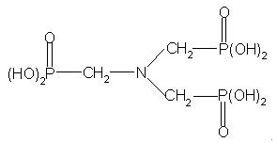
Product Grade | Industrial
Description  & Application | A scale and corrosion inhibitor for cooling circulation water system and oilfield water pipeline in fields of thermal power plant and oil refinery plant; Metal chelate agent and color fixing agent for print and textile; Complexing agent for electron plate and water scale cleaning agent for metals.
Safety Protection | Acidity, avoid contact with eye and skin, once contacted, flush with water.
Specification | Active content (as acid)% : ≥95  Chloride (as Cl-)%: ≤1.0  Phosphorous acid %: ≤4.5  pH(1% solution): ≤ 2.0  Iron(as Fe) ppm: ≤35  Appearance：white crystal powder
Package | 25kg/bag.,Stored in cool and dry place.
Shelf Life | 1 year.

