PRODUCT DATA SHEET
OIT 45%
Synonyms | 2-n-Octhl-4-isothiazolin-3-one 45%
CAS Number | 26530-20-1
Einecs Number | 247-761-7
UN No.
Molecular Formula | C₁₁H₁₉NOS
Molecular weight | 213.33
Structural Formula | 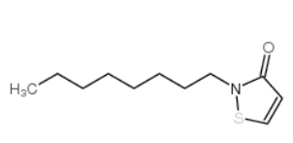
Product Grade | Industrial
Description  & Application | OIT has good antibacterial effect bacteria, mold, saccharomycetes and algae, widely used as antiseptic of coating dry film, coating emulsion and paint.
Safety Protection | Avoid contact with eye and skin, once contacted, flush with water.
Specification | OIT% : 45min  Density (20℃, g/ml): 1.02-1.05  Water %: 1.0 max  Appearance：clear yellow to light brown liquid
Package | 25KG in plastic drum, Stored in cool and dry place.
Shelf Life | 1 year.

