PRODUCT DATA SHEET
BKC
Synonyms | Benzalkonium Chloride
CAS Number | 139-07-1 & 139-08-2
Einecs Number | 205-351-5 & 205-352-0
UN No. | 1760
Molecular Formula | C21H38ClN & C23H42NCl
Molecular weight | 339.99 & 368.04
Structural Formula | 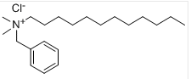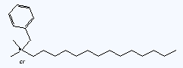
Product Grade | Industrial
Description  & Application | BKC is one of the Quaternary ammonium class of Cationic surfactants, belonging to nonoxidizing biocide. It is widely used as a disinfectant in the Hospital, Livestock and Personal Hygiene sectors. Dual biocidal and detergency properties ensure high efficacy against Bacteria, Algae and Fungi and enveloped Viruses at exceptionally low ppm concentrations. BKC also has dispersing and penetrating properties, with advantages of low toxicity, no toxicity accumulation, soluble in water, convenient in use, unaffected by water hardness. BKC can be also used as anti-mildew agent, antistatic agent, emulsifying agent and amendment agent in woven and dyeing fields.
Safety Protection | Avoid contact with eye and skin, once contacted, flush with water.
Specification | Appearance: Clear pale yellow transparent liquid  Active content (%) ≥ 80  Amine salts (%) ≤1.0  Free amine (%) ≤1.0  Viscosity(40˚C) (cps) ≤130.0  PH (1%solution) 6.0-8.0  Density(150˚C˚C) (g/cm3) 0.96±0.01
Package | 250L Drum, 1000L IBC or Bulk. Stored in cool and dry place.
Shelf Life | 1 year.

